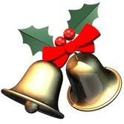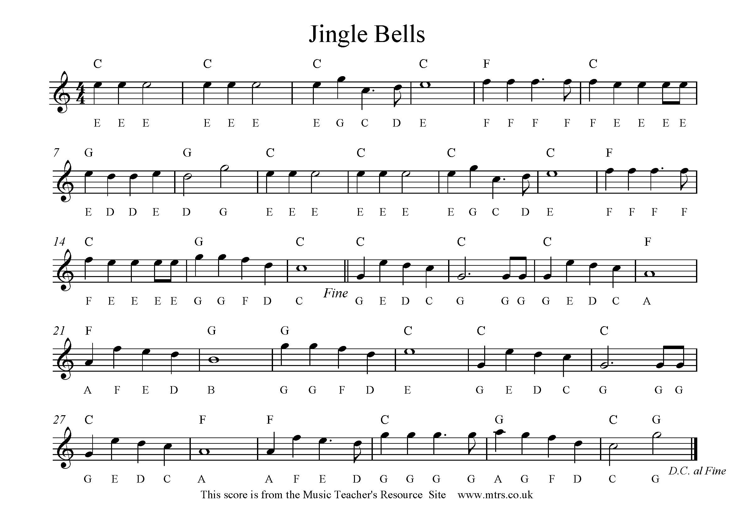

Play the right and left together for

5c

Play the right hand through for a level 4a

**Chords- C= CEG F= FAC G=GBD** Play the chords and right hand for a level 5a

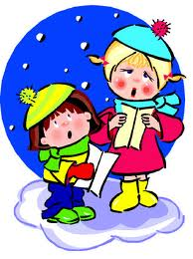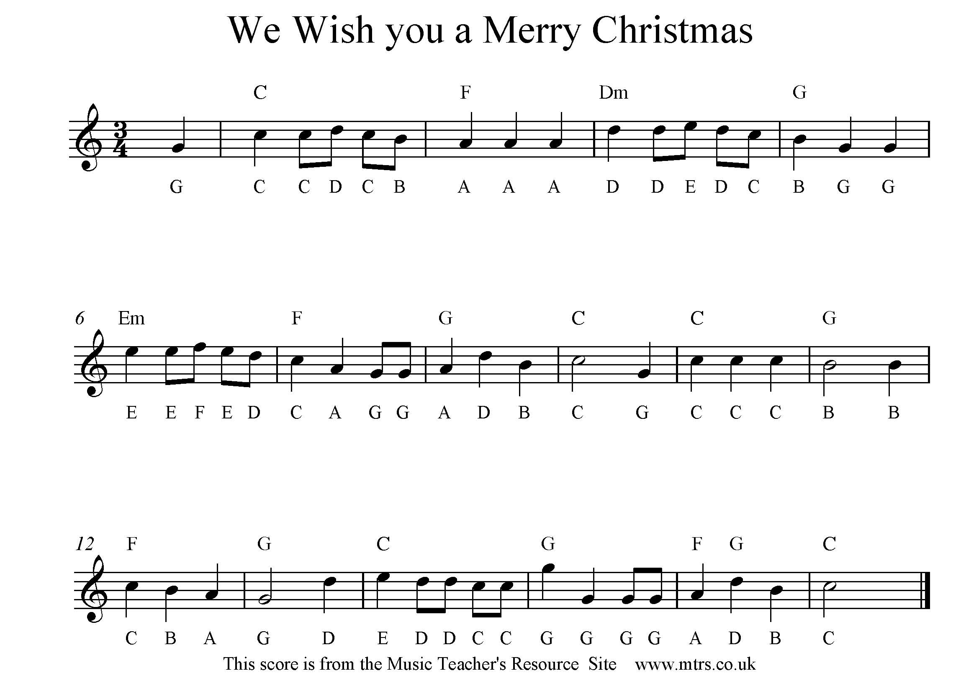 [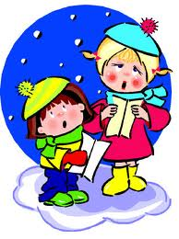](http://www.google.co.uk/imgres?imgurl=http://www.asksam.com/ebooks/christmas-carols/christmas-carols.jpg&imgrefurl=http://www.asksam.com/ebooks/christmas-carols/&usg=__wKEVeB2mia5t1noAlvzpYglIxKo=&h=425&w=317&sz=52&hl=en&start=0&zoom=1&tbnid=IUrP8J3XTH8-EM:&tbnh=155&tbnw=116&prev=/images?q=christmas&um=1&hl=en&safe=active&noj=1&biw=1007&bih=634&tbs=isch:1&um=1&itbs=1&iact=hc&vpx=129&vpy=53&dur=219&hovh=260&hovw=194&tx=117&ty=124&ei=qEAHTdQGi5iFB-GR3RQ&oei=qEAHTdQGi5iFB-GR3RQ&esq=1&page=1&ndsp=13&ved=1t:429,r:0,s:0) [](http://www.google.co.uk/imgres?imgurl=http://www.asksam.com/ebooks/christmas-carols/christmas-carols.jpg&imgrefurl=http://www.asksam.com/ebooks/christmas-carols/&usg=__wKEVeB2mia5t1noAlvzpYglIxKo=&h=425&w=317&sz=52&hl=en&start=0&zoom=1&tbnid=IUrP8J3XTH8-EM:&tbnh=155&tbnw=116&prev=/images?q=christmas&um=1&hl=en&safe=active&noj=1&biw=1007&bih=634&tbs=isch:1&um=1&itbs=1&iact=hc&vpx=129&vpy=53&dur=219&hovh=260&hovw=194&tx=117&ty=124&ei=qEAHTdQGi5iFB-GR3RQ&oei=qEAHTdQGi5iFB-GR3RQ&esq=1&page=1&ndsp=13&ved=1t:429,r:0,s:0)

Play the right hand through for a level 4a

**Chords- C= CEG F= FAC Dm= DFA G=GBD Em= EGB** Play the chords and right hand for a level 5a

Play the right and left together for

5c

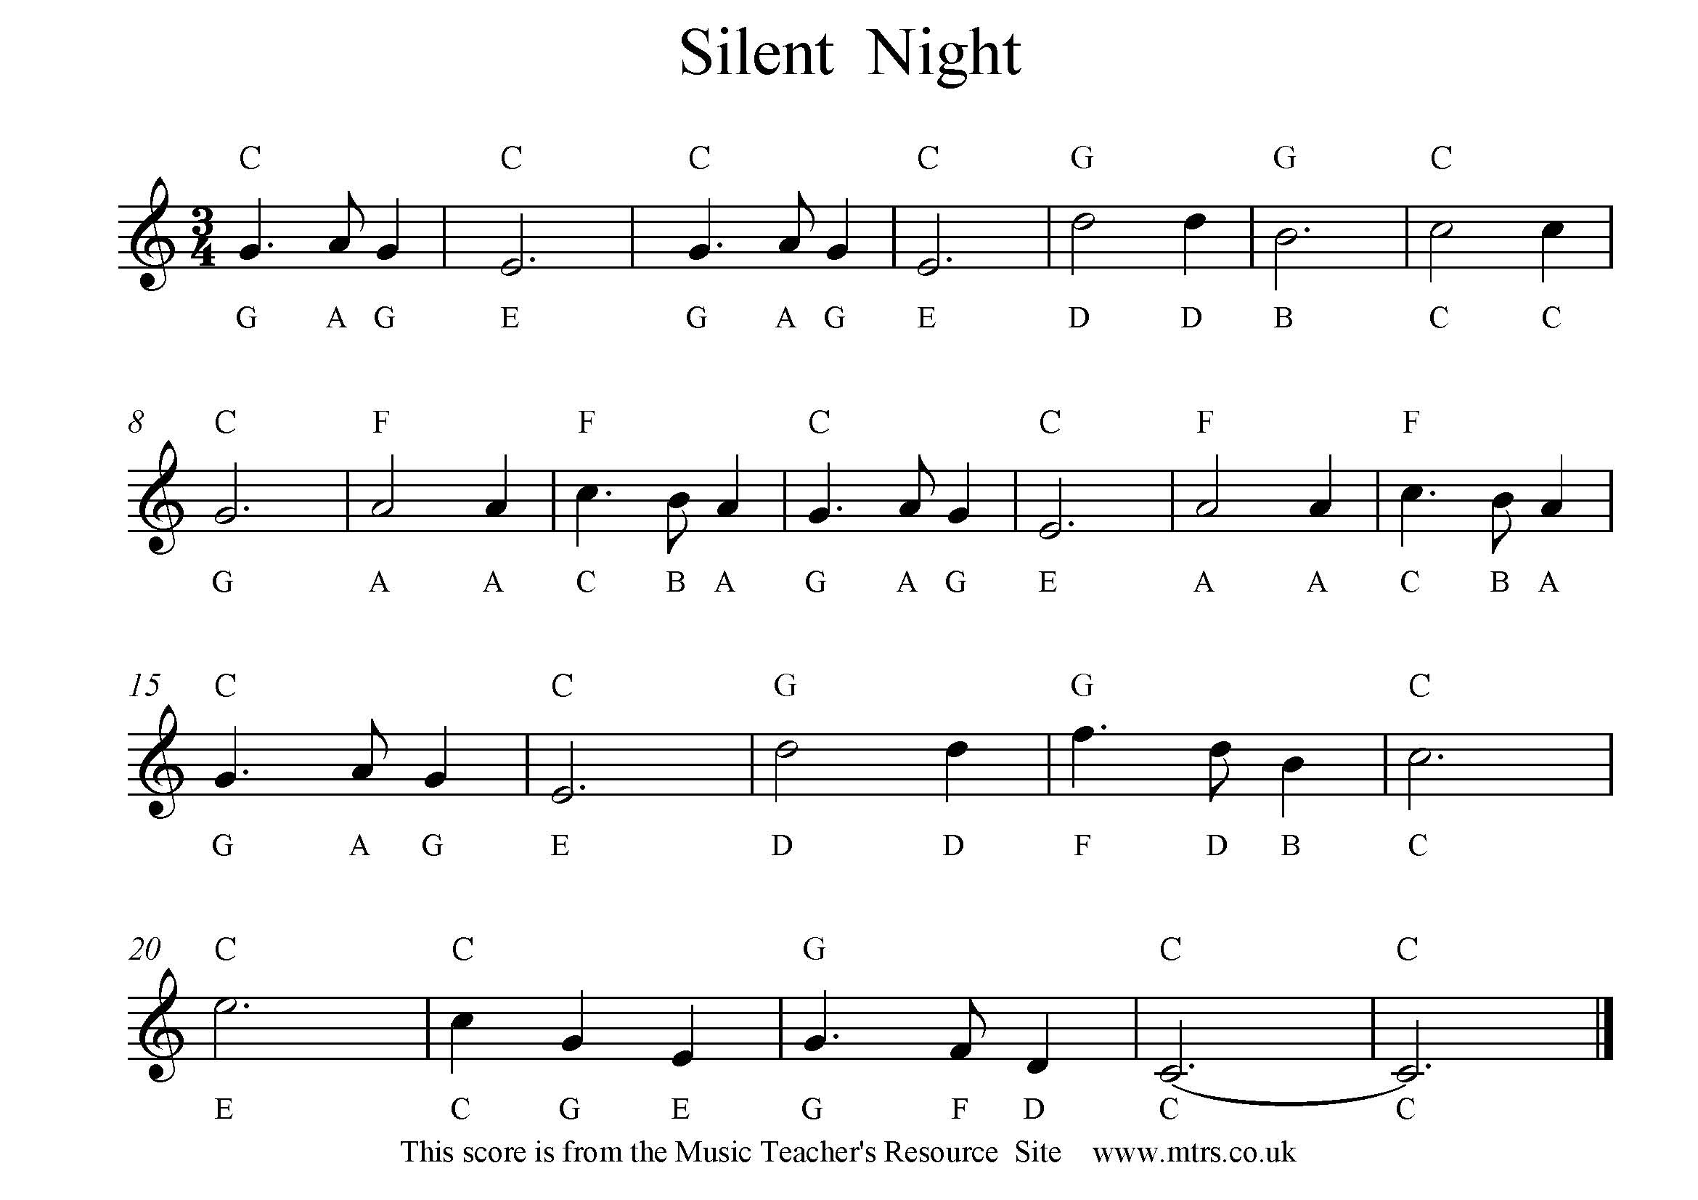

Play the right hand through for a level 4c/4b

Play the right and left together for 4a

Play the chords and right hand for a level 5c

**Chords- C= CEG F= FAC G=GBD** Play the chords and right hand for a level 5c

  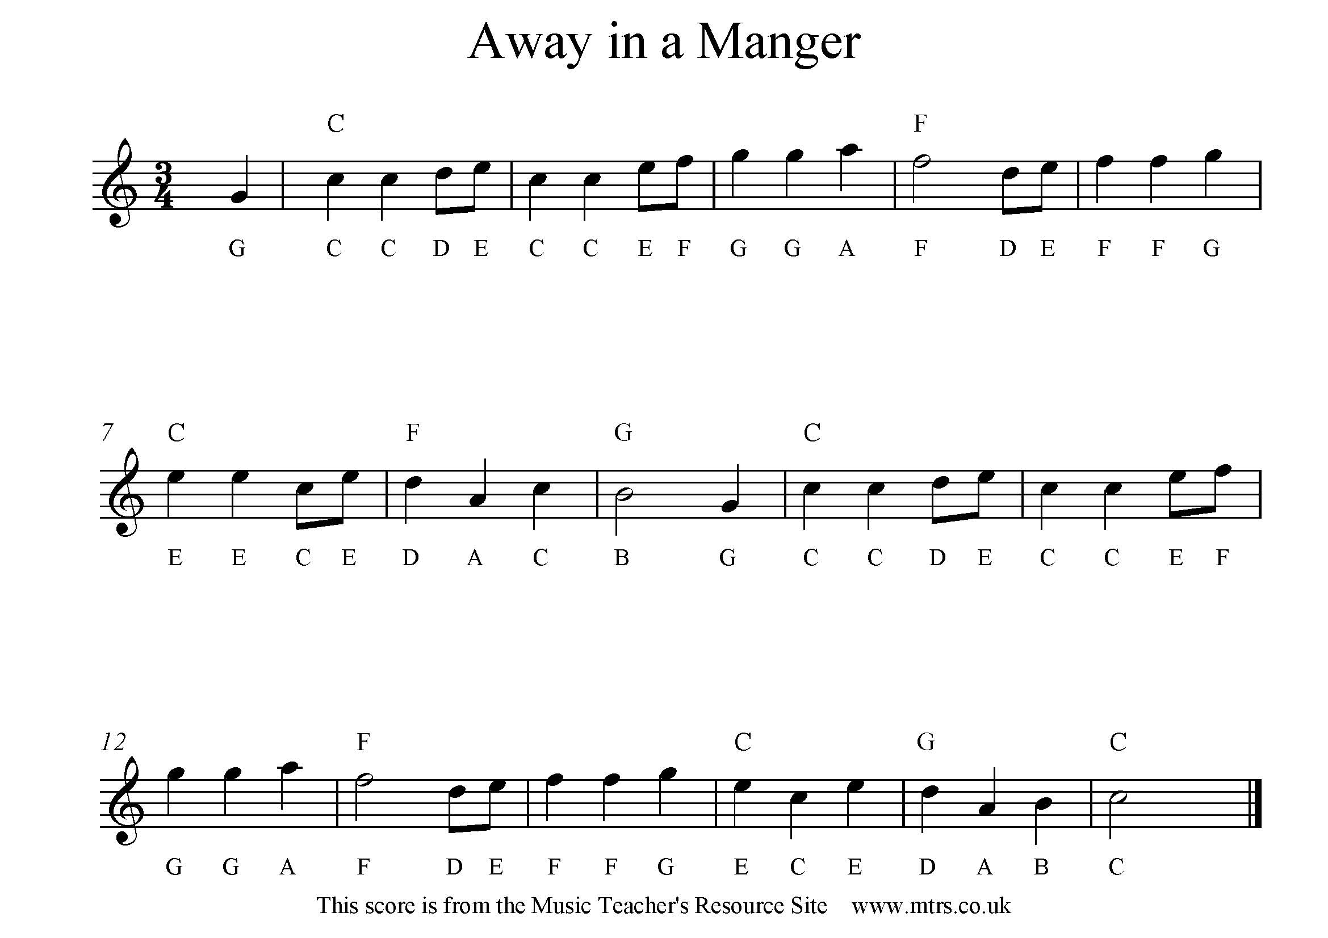

Play the right hand through for a level 4c/4b

Play the right and left together for 4a

Play the chords and right hand for a level 5c

**Chords- C= CEG F= FAC G=GBD** Play the chords and right hand for a level 5c